GOVERNMENT ART’S AND SCIENCE COLLEGE

SRIVILLIPUTTUR.

1.INTRODUCTION :

India's agricultural landscape has been a cornerstone of its economy and sustenance for centuries, and the period from 1997 to 2021 witnessed significant developments in crop production. This era marked a critical juncture in the history of Indian agriculture, reflecting changes in technology, policies, and environmental factors that shaped the nation's crop production. In this analysis, we will delve into the intricate tapestry of India's agriculture, examining key trends, challenges, and achievements from 1997 to 2021. This period saw India transitioning from a nation grappling with food security issues to a major agricultural force on the global stage. We will explore the factors contributing to this transformation, including the Green Revolution, biotechnological advancements, changing weather patterns, government initiatives, and the resilience of India's farming communities. By examining this 25-year span, we aim to gain insights into the evolving dynamics of India's crop production, its socio-economic implications, and the lessons it offers for sustainable agricultural development in the future.

1.1.OVERVIEW :

1. **Green Revolution and Its Legacy:** The analysis begins with the lingering impacts of the Green Revolution, which began in the 1960s. High-yielding crop varieties, advanced irrigation, and increased use of fertilizers played a vital role in transforming India into a food surplus nation.
2. **Crop Diversification:** India transitioned from primarily being a wheat and rice producer to diversifying its crop portfolio. The period saw increased cultivation of cash crops like cotton, soybeans, and oilseeds.
3. **Technological Advancements:** The adoption of modern agricultural technologies, including genetically modified crops and precision farming, significantly improved crop yields and quality.
4. **Environmental Concerns:** The analysis delves into the environmental concerns and challenges faced during this period, including water scarcity, soil degradation, and pesticide usage.
5. **Government Policies and Initiatives:** A major focus is on various government policies and initiatives, such as Minimum Support Prices (MSPs), subsidies, and the Pradhan Mantri Krishi Sinchai Yojana (PMKSY), designed to boost agricultural productivity and income for farmers.
6. **Climate Change Impact:** The period also witnessed the growing influence of climate change on agriculture, with altered monsoon patterns, extreme weather events, and increased pressure for sustainable farming practices.

1.2.PURPOSE :

1. **Historical Understanding:** To provide an in-depth historical perspective on the evolution of agriculture in India during this 25-year period. This understanding helps in recognizing the key trends and transformations that have occurred.
2. **Policy Evaluation:** To assess the effectiveness of government policies and initiatives related to agriculture during this period. Understanding what worked and what didn't is crucial for informed policy development.
3. **Sustainability Assessment:** To gauge the sustainability of India's agriculture practices during this time frame, particularly in the face of environmental challenges like climate change, water scarcity, and soil degradation.
4. **Economic Impact:** To measure the economic impact of changes in crop production on India's overall economy, including the contribution of agriculture to GDP, income distribution among farmers, and its role in rural development.
5. **Food Security and Nutrition:** To examine the implications for food security and nutrition in India, including the ability of the country to produce enough food to meet the dietary needs of its population.
6. **Technological Advancements:** To understand the role of technological advancements, including biotechnology, precision agriculture, and mechanization, in enhancing crop production and overall agricultural productivity.

2.PROBLEM STATEMENT & DESIGN THINKING :

**STATEMENT :**

**"India's agriculture sector, spanning from 1997 to 2021, faces multifaceted challenges that impact food security, economic sustainability, environmental stewardship, and the well-being of millions of farmers. This analysis aims to identify and address these challenges, foster innovation, and design holistic solutions to ensure a prosperous, sustainable, and resilient agricultural future for the nation."**

**DESIGN THINKING APPORACH:**

**Empathize:**

* Begin by empathizing with the key stakeholders, including farmers, agricultural workers, policymakers, scientists, and consumers, to understand their perspectives, needs, and pain points. This involves conducting interviews, surveys, and ethnographic research to gain deep insights into the challenges and aspirations of these stakeholders.

**Define:**

* Define the specific problems and challenges within India's agriculture sector during the 1997-2021 period. Prioritize these problems based on their impact, urgency, and feasibility of resolution. Key problem areas may include stagnating crop yields, soil degradation, farmer distress, unequal access to resources, and environmental sustainability.

**Ideate:**

* sBrainstorm and generate innovative ideas and solutions to address the identified problems. Encourage cross-disciplinary collaboration among experts in agriculture, technology, economics, and environmental science. Promote creativity and out-of-the-box thinking to develop a range of potential solution.

**Prototype:**

* Develop prototype solutions or pilot projects that address the defined problems. These prototypes may include new farming techniques, technologies, policies, or community-driven initiatives. The goal is to create tangible representations of potential solutions that can be tested and refined.

**Test:**

* Implement the prototypes in real-world settings or representative environments. Collect data and feedback from stakeholders to assess the effectiveness of these solutions. Iteratively refine the prototypes based on the insights and outcomes from these tests.

**Implement:**

* Based on the feedback and results from the testing phase, choose the most viable and effective solutions. Develop a comprehensive implementation plan, including the necessary policies, resources, and collaborations needed to scale up these solutions across the agricultural landscape.

2.1.EMPATHY MAP :

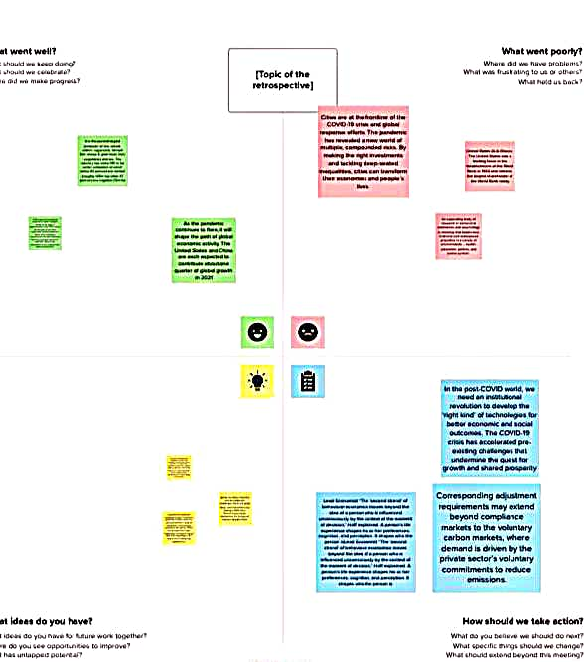

2.2.IDEATION AND BRAINSTORMING MAP :

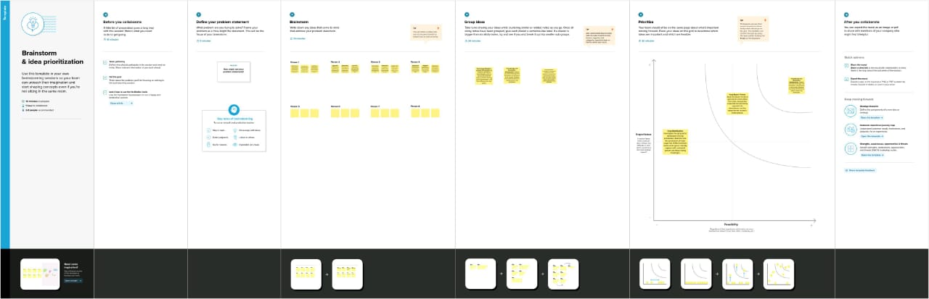

3.RESULT :

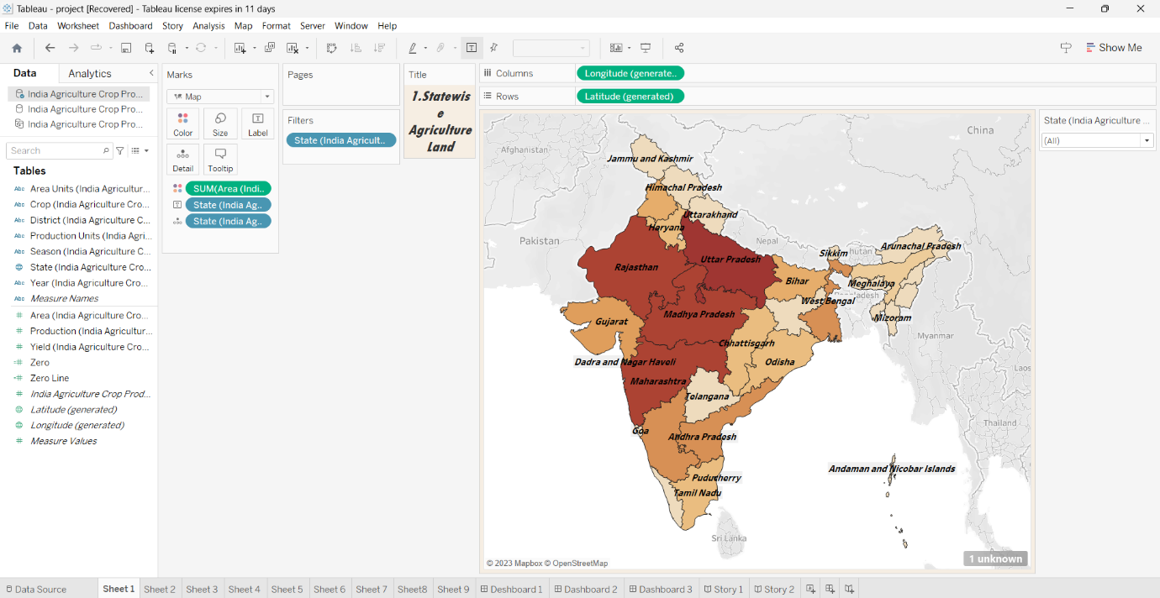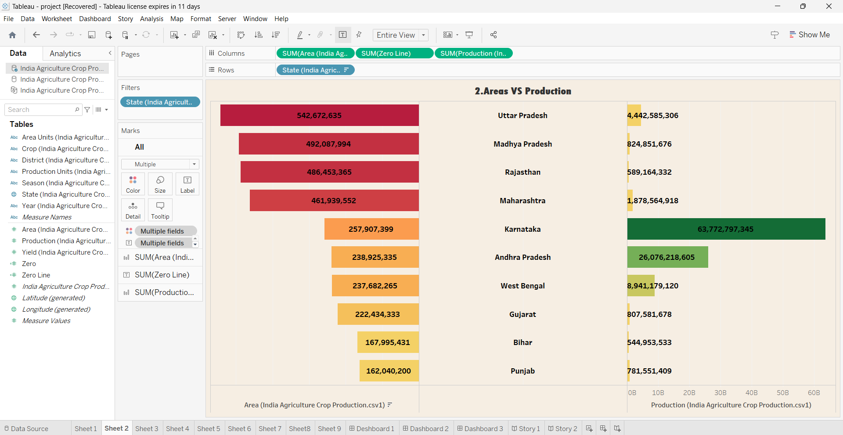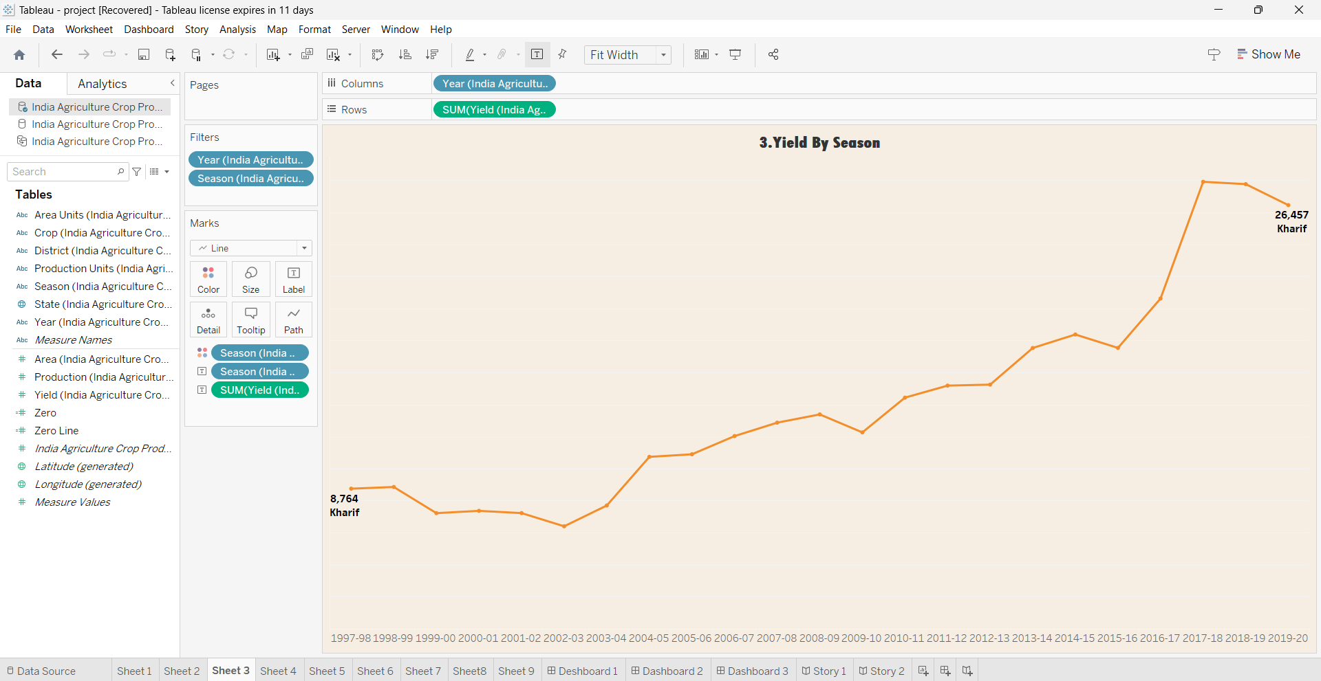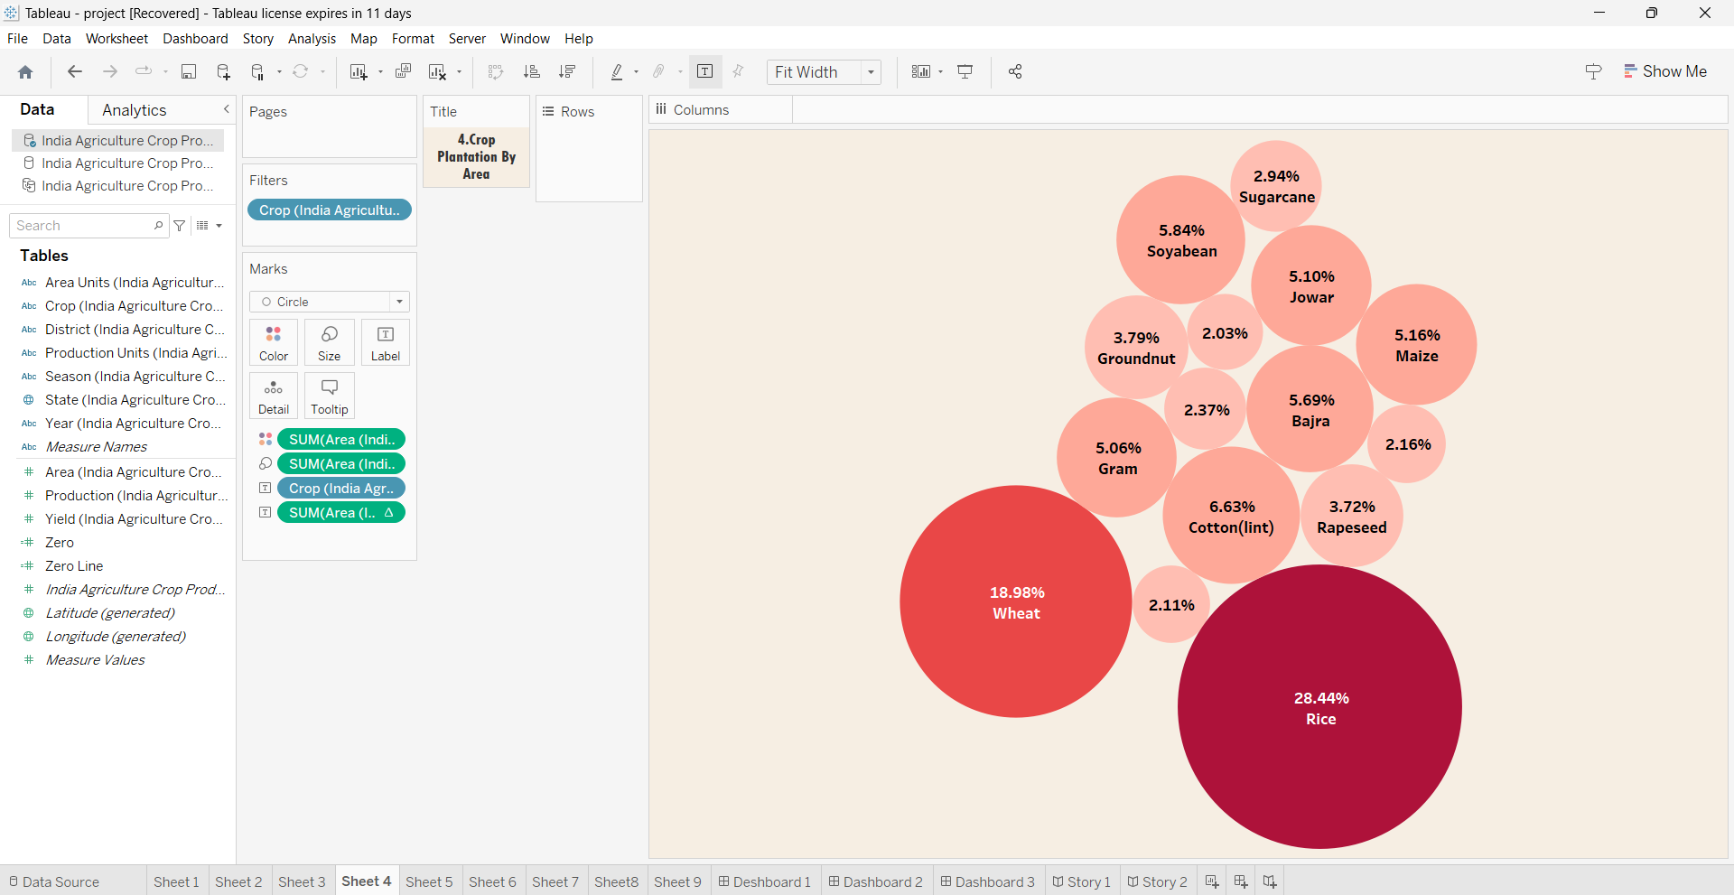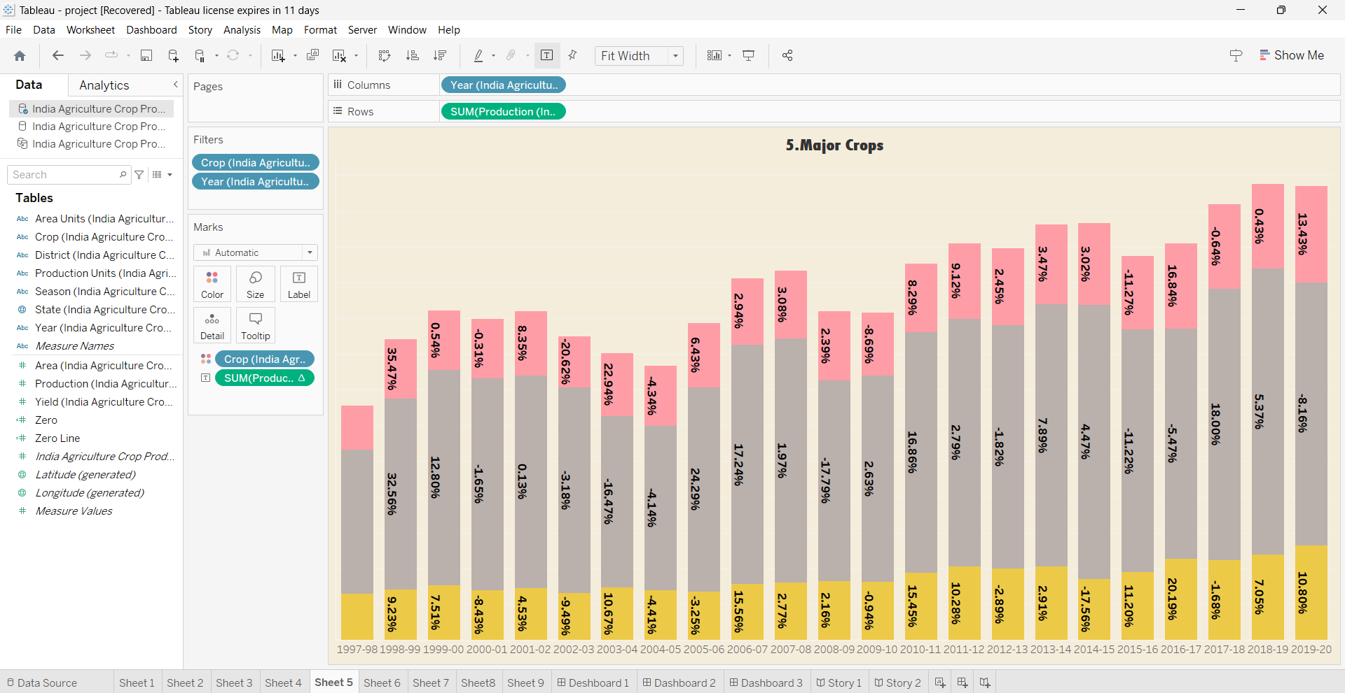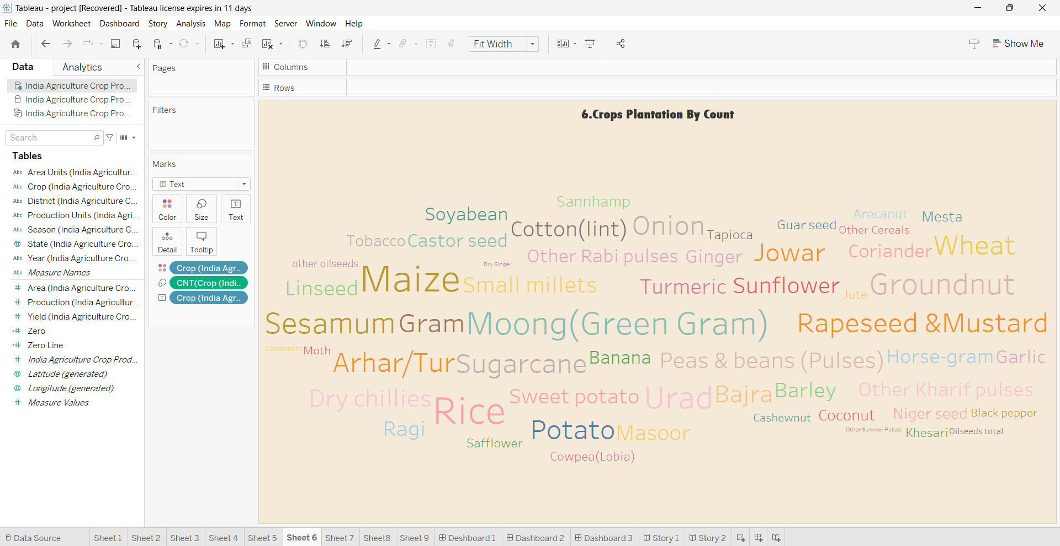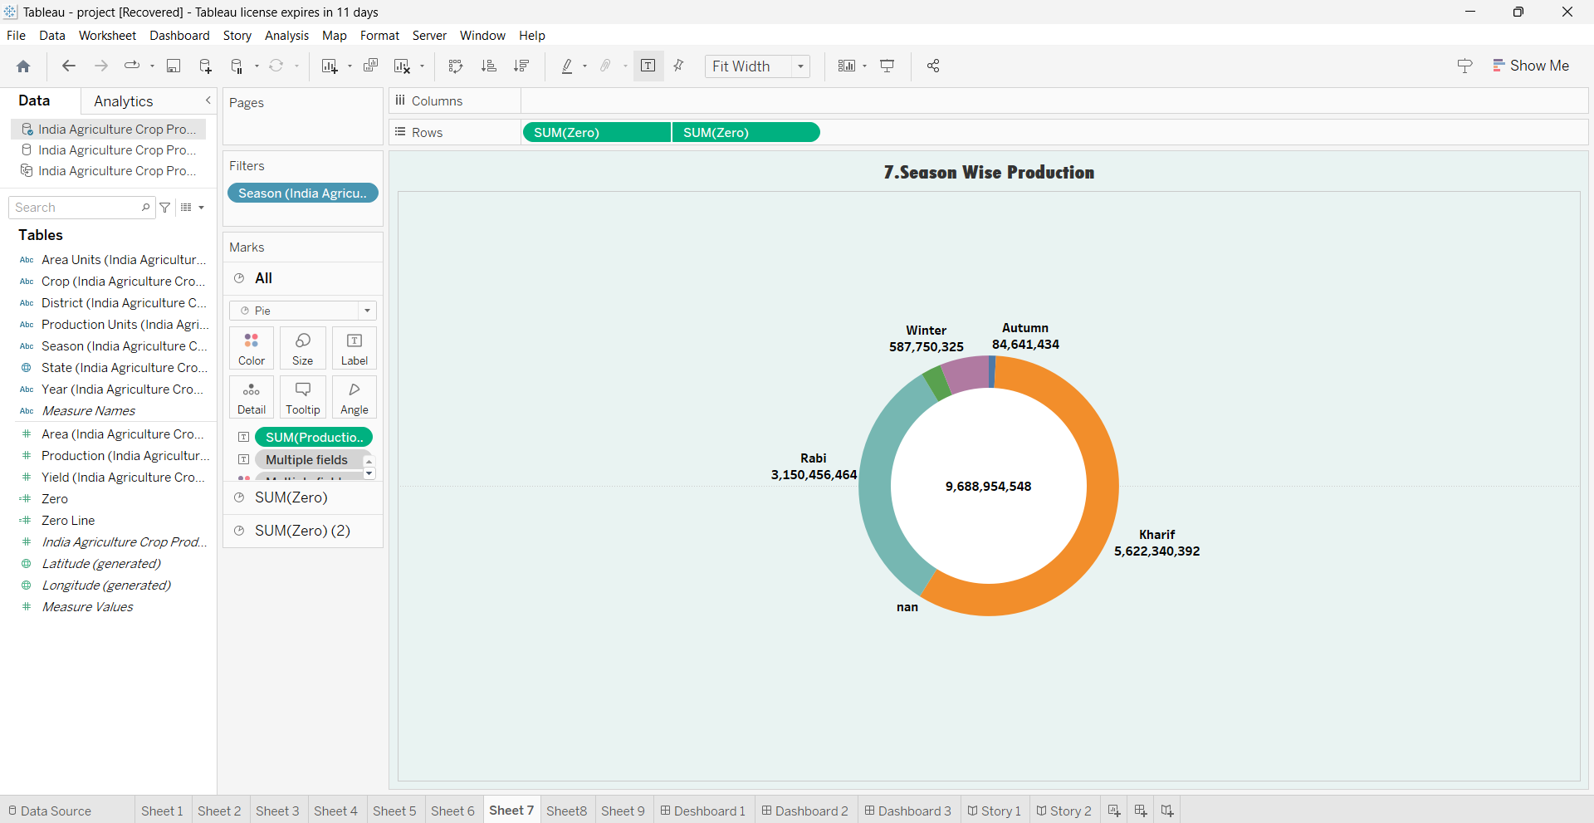: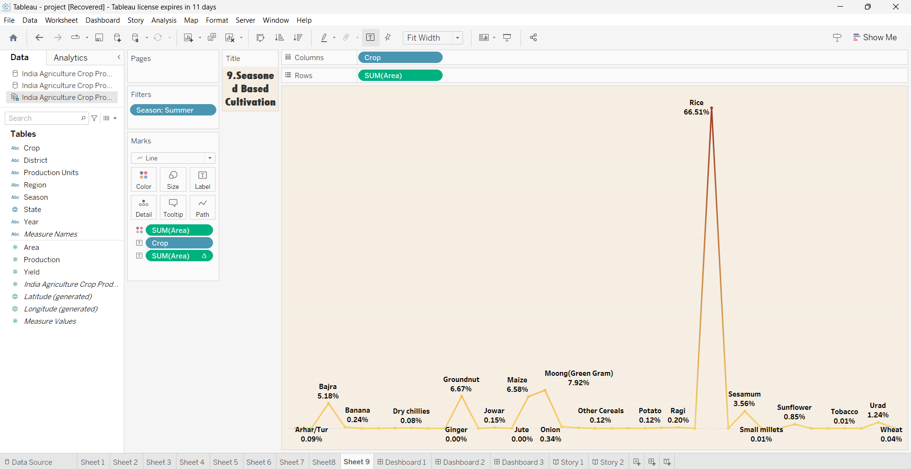

4.ADVANTAGES & DISADVANTAGES :

**Advantages of India's Agriculture 1997-2021 Analysis:**

1. **Informed Decision-Making:** Comprehensive analysis provides policymakers, researchers, and stakeholders with data and insights to make informed decisions and formulate effective agricultural policies.
2. **Identifying Successes:** It helps recognize successful agricultural practices and policies, allowing for their replication and scaling up.
3. **Agricultural Growth:** The analysis can highlight periods of significant agricultural growth and identify factors contributing to increased crop production and food security.
4. **Sustainable Practices:** It offers an opportunity to pinpoint sustainable agricultural practices that can be promoted and adopted to ensure long-term food security and environmental stewardship.
5. **Innovation and Technology:** By assessing technological advancements, the analysis can showcase innovations that have improved productivity, reduced post-harvest losses, and enhanced crop quality.
6. **Economic Insights:** It provides economic data on the agriculture sector's contribution to the national economy, employment, and rural development, aiding in resource allocation.

**Disadvantages of India's Agriculture 1997-2021 Analysis:**

1. **Data Quality:** The accuracy and reliability of historical agricultural data can be a concern, potentially leading to misinterpretations and incorrect conclusions.
2. **Complexity:** Agriculture is a multifaceted sector with numerous variables and interdependencies, making analysis challenging and subject to oversimplification.
3. **Inequality:** The analysis may reveal disparities in the distribution of benefits among farmers and regions, highlighting social and economic inequalities within the sector.
4. **Policy Bias:** The results of the analysis can be influenced by political biases, potentially leading to skewed policy recommendations.
5. **Environmental Impact:** It may reveal negative environmental consequences of intensive farming practices, highlighting issues such as soil degradation, water scarcity, and pesticide usage.
6. **Retroactive Focus:** The analysis may primarily focus on past trends and may not provide real-time solutions to ongoing and emerging challenges in agriculture.

5.APPLICATIONS :

1. **Policy Formulation:** The analysis can serve as a valuable resource for policymakers in shaping agricultural policies. It provides insights into what has worked and what needs improvement, helping in the design of evidence-based agricultural policies.
2. **Sustainable Agriculture Initiatives:** By identifying sustainable practices and success stories, the analysis can inform initiatives and programs that promote eco-friendly and resilient agricultural practices.
3. **Resource Allocation:** Governments can use the analysis to allocate resources efficiently, ensuring that financial and infrastructural support is directed towards areas and practices that need it the most.
4. **Agricultural Education:** Educational institutions can use the analysis to develop curriculum materials that reflect the historical context and current challenges in Indian agriculture.
5. **Investment and Funding Decisions:** Investors and funding agencies can use the analysis to make informed decisions on investments in agricultural technologies, startups, and infrastructure.

6.CONCLUSION :

**1. Achievements in Food Security:** India's Green Revolution legacy played a pivotal role in catapulting the country from a state of food scarcity to self-sufficiency and beyond. The nation's capacity to produce essential grains, primarily wheat and rice, substantially improved, ensuring that a growing population had access to an adequate food supply.

**2. Crop Diversification:** The period under analysis saw the diversification of crops, shifting from a primary focus on wheat and rice to the cultivation of cash crops like cotton, soybeans, and oilseeds. This diversification has helped mitigate risks associated with monoculture and has created new income opportunities for farmers.

**3. Technological Advancements:** The adoption of advanced technologies, including genetically modified crops, precision agriculture, and improved irrigation methods, boosted crop yields and quality. These innovations played a significant role in enhancing agricultural productivity and ensuring food security.

**4. Environmental Concerns:** The analysis has underscored the environmental challenges of intensive farming practices, including soil degradation, water scarcity, and overreliance on pesticides. These concerns highlight the urgent need for sustainable agricultural practices that preserve natural resources for future generations.

**5. Income Disparities:** Income disparities among farmers and regions continue to be a pressing issue. The analysis has shed light on the unequal distribution of benefits within the agricultural sector, underscoring the importance of policies that address this disparity.

7.FUTURE SCOPE :

1. **Sustainable Agriculture Practices:** The analysis can inform the development and promotion of sustainable farming practices. Future initiatives can focus on reducing the environmental impact of agriculture, conserving resources, and preserving soil and water quality.
2. **Climate Resilience:** Given the increasing impacts of climate change, the analysis can guide strategies for climate resilience in agriculture. This includes the development of crop varieties and practices that are more resilient to changing weather patterns.
3. **Technology Adoption:** Future scope involves the accelerated adoption of advanced technologies in agriculture. This can include precision farming, artificial intelligence, remote sensing, and the use of data analytics to optimize farm management.
4. **Income Equality:** Policies and initiatives can be designed to address income disparities among farmers. Efforts can be made to ensure that the benefits of agricultural growth are equitably distributed, especially to smallholder farmers.
5. **Diversification:** Building on the analysis, future efforts can encourage diversification into high-value and climate-resilient crops and agricultural products, reducing the dependency on traditional crops.